Katari Taiko
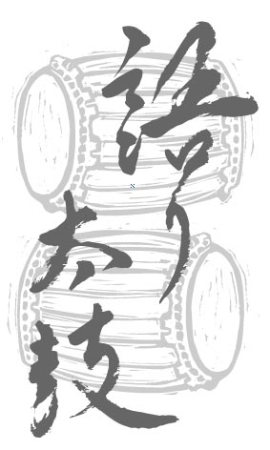

FEBRUARY 2020

WORKSHOP

THREE HOUR EVENING WORKSHOP: Tuesday, February 11, 2020 6:30-9:30 pm
Learn about fundamental taiko drumming techniques and rhythms and explore the context of taiko as a performing art within the Japanese Canadian community in this three-hour, hands-on evening workshop. No previous experience is necessary.

Venue: Vancouver Japanese Hall, 487 Alexander Street
Fee: $40 general or $30 for students/ seniors/ underemployed. Participants must be a minimum of 16 years of age.
Please wear loose, comfortable clothing and bring soft-soled indoor athletic footwear.

Please call 604-728-8240 before sending the registration form below and payment to Katari Taiko to:
Katari Taiko Workshop Registration
#410 – 111 Hastings Street West, Vancouver, BC V6B 1H4
E-mail: diane@dkam.ca; www.kataritaiko.bc.ca
Applicants will be accepted on a first come, first served basis to a maximum of 15. Registration will be confirmed after the fee is paid.

Please Become A Member!
Katari Taiko Drum Group Association is a non-profit society dedicated to educating Canadians about the history, art and performance of traditional and contemporary taiko music (Japanese drumming). Your membership shows your support for the work of Katari Taiko. You will receive news and notices of upcoming performances and the annual general meeting.

--------------------------------------------------------------------detach and send------------------------------------------------------------------------------------------------------------------------------

WORKSHOP AND MEMBERSHIP REGISTRATION:
Name:
Address:
City: ______________________________Province: Postal Code:
E-mail: ____________________________Tel (day): __________________Tel (eve): _____________________

Please check all that apply:
□ Please register me for the evening workshop on Tues, February 11, 2020.
□ I would like to become a member of the Katari Taiko Drum Group Association.

Workshop fees, CDs, memberships and donations (please check all that apply):
□ Workshop (employed) $40
□ Workshop (student/senior/underemployed) $30
□ Katari Taiko: T-shirt $30 (incl.GST/PST)
□ Commotion: CD $10 (incl.GST/PST, P&H)
□ Itadakimasu: CD $10 (incl.GST/PST, P&H)
□ Membership $2
□ Tax Deductible Donation (enter amount)

Enclosed is a cheque payable to Katari Taiko for: Total

